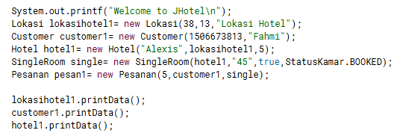

1. Print data object lokasi, customer, dan hotel.

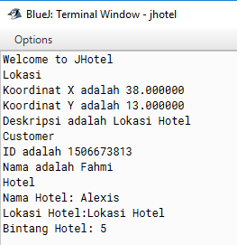

1. Jalankan method pesananDitugaskan()

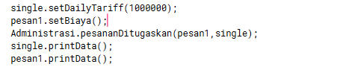

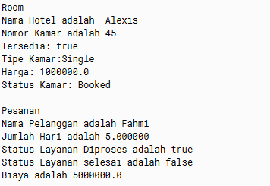

Pengecekan Single Room

